Analysis, Design & Testing

SEG2012GP9

|  |  |
| --- | --- |
| Seabrook, Edward J F | [ejfs1g10@ecs.soton.ac.uk](mailto:ejfs1g10@ecs.soton.ac.uk) |
| Elliott, Kristian | [ke1g10@ ecs.soton.ac.uk](mailto:ke1g10@soton.ac.uk) |
| Yu, Brian | [by2g10@ ecs.soton.ac.uk](mailto:by2g10@soton.ac.uk) |
| Mariani Elola, Oscar N | [onme1g10@ ecs.soton.ac.uk](mailto:onme1g10@soton.ac.uk) |
| Chan, Yun Chak | [ycc1g11@ ecs.soton.ac.uk](mailto:ycc1g11@soton.ac.uk) |

# Document Control

|  |  |  |
| --- | --- | --- |
| **Version** | **Author** | **Changes** |
| 1 | ejfs1g10 | Initial document |
| 2 | onme1g10 | Added conceptual model of HCI |
| 3 | ke1g10 | Added the approach taken |
| 4 | ejfs1g10 | Various stylistic alterations |
| 5 | ejfs1g10 | Added Class diagram |
| 6 | by2g10 | Added state chart |
| 7 | onme1g10 | Added wireframes |
| 8 | by2g10 | Added test cases for dialogs |
| 9 | ejfs1g10 | Wrote analysis documentation |
| 10 | onme1g10 | Added test cases for the model, and JUnit code to the appendix |
| 11 | ycc1g11 | Added more test cases for model |
| 12 | ke1g10 | Reviewed document |
| 13 | onme1g10 | Proof read document |
| 14 | ejfs1g10 | Ensured stylistic consistency |

# Table of Contents

Document Control 2

Table of Contents 3

1 Approach Taken 4

1.1 Technical 4

1.2 Modelling 5

2 Analysis Documentation 6

2.1 Requirements Analysis 6

2.2 Design Analysis 6

2.2.1 Model 6

2.2.1.1 Airport 6

2.2.1.2 Email 7

2.2.1.3 Loading and Saving XML 7

2.2.2 View 8

2.2.3 Controller 8

2.3 Interface Design 9

3 Testing 10

3.1 Test Plan 10

3.2 Test Report 10

3.1.2 Unit Testing 10

3.2.1 Integration Testing 13

3.2.3 User Acceptance Testing 15

Appendix A – Sequence Diagram 16

Appendix B – Class Diagram 17

Appendix C – Use Case Diagram 18

Appendix D – State Chart 19

Appendix E – Wireframes 20

Appendix F – JUnit Tests 21

# 1 Approach Taken

## 1.1 Technical

We plan to make use of many different tools in throughout our project:

1. **Java** - The project specification requires that we work in the Java programming language; this works well as we have all had experience working with Java and are familiar with it.

1. **Eclipse** - has been chosen by our group as our preferred development environment. The reason for this choice is that it is a good, extensible Java IDE (Integrated Development Environment) with features such as autocomplete that enable us to write code faster than in a standard text editor. Eclipse is also cross platform which is a great benefit since we use a range of Operating Systems within our group. We all have experience using Eclipse.
2. **JUnit** – we will create tests for our application in JUnit to ensure we produce a robust code base.
3. **Google Window Builder Pro** - this Eclipse plugin shall be used to speed up the creation of Graphical User Interfaces for the program.
4. **Microsoft Word 2010** – Shall be used to produce the formal documentation and reports for the project. Word is good at handling medium sized documents and is easy to style to the house guidelines. We shall however submit our reports as PDF files to ensure good compatibility.
5. **Google Docs -** will be used as scratch space for rough notes and ideas, and also to circulate agendas before meetings. Google Docs was chosen because it has been designed to facilitate collaboration. Google Docs also offers a spread sheet application that we shall be using to log out time spent.
6. **ECS ugForge** - We shall use this service to host our version control repository. We shall make regular commits of our work to ensure high levels of transparency on the work being done, and allow rollbacks if a major error is found in our work.
7. **SmartSheet[1]** – We shall be using this web based service as it produces clean, maintainable charts. Using this software will allow us to monitor our progress and decide which tasks to perform next. Frequent updates to the chart will ensure it reflects the real world.
8. Many types of diagram will be used to help us understand various aspects of the project:
   1. **Use Case diagrams** - produced in **Visual Paradigm**, shall help us identify and comprehend all of the use cases from the requirements.
   2. **Class diagrams** - produced using **PlantUML** (a text based UML tool), allow us to break the software into classes that can be coded.
   3. **Sequence diagrams** – also created using **Visual Paradigm** show how the classes are meant to interact within the system.
   4. **Wireframes** - of the user interface will be produced using **Balsamiq Mockups** to help us develop a user friendly user interface.
   5. **State charts** – also produced using **PlantUML**, shows the various states of the software

## 1.2 Modelling

To produce good quality, extensible software, a number of different abstractions and architectural styles have been adopted throughout our application:

1. The project specification mandates the use of Model-View-Controller architecture[2]. This architecture separates the classes of the system into three different categories.
   1. The **Model** classes are concerned with the problem domain – all the business logic and calculations for the application are stored in the Model classes.
   2. The **View** classes perform all of the drawing to the screen. In Java these are the Swing classes that produce the user interface. There will be classes for the various windows and controls used in the application. We shall extend many standard controls to meet our requirements.
   3. The **Controller** classes interact with both the View classes and the Model classes. In essence, the Controller tells the Model to update and lets the View know that the Model has been updated so it can redraw the data.

We have chosen to keep the three groups of classes very separate, splitting into pairs to develop them, this allows the program to be more extendable, as the coupling is very low.

1. We shall make extensive use of the Iterator Pattern through the use of the Java enhanced-for loop. This construct allows us to easily traverse over all elements of container classes consisting of Lists of airports, runways and other classes.
2. The Observer Pattern will be used to ensure that every object that is concerned with the values of Airport will be kept consistent when a new Airport is loaded in from a file. An interface AirportObserver shall be implemented by these classes, completing a method updateAirport(Airport) that performs the required behaviour when the airport changes. These classes shall then be added to a List of classes that are observing the Airport. Whenever the airport is changed, the method that changed it shall call a method that iterate through all of the interested objects, calling their notify method.
3. We chose to base many of the Model classes in our project on real life objects
   1. The Runway class shall be based on the abstract declaration of a runway and, along with another instance of the same class, will be contained inside a PhysicalRunway class that represents the real world runway. As many as required of these objects can then be stored inside an Airport class.
   2. For the email section of our program everything shall be wrapped up in classes. The functionality of sending an email, will be contained within a class called Email. This makes it easy for other objects to call on this function without in depth knowledge of how it must be set up. To ease sending emails to commonly used email addresses, the classes Contact, and its container AddressBook shall be available.

# 2 Analysis Documentation

In producing our software a lot of thought and discussion was undertaken to decide on the best design, ensuring our application would be able to fulfil its needs to an excellent standard.

## 2.1 Requirements Analysis

The first thing we needed to do was understand the problem that we had been given. We started by reading the specification and various pieces of background information provided by the CAA (Civil Aviation Authority). In our early meetings, we discussed what we had read and came to agreements on our interpretations of the information.

We identified the use cases of our project and compiled them into a use case diagram[3] to help us communicate with one another the requirements. The diagram shows that the intended user of the software is Air traffic controllers and engineers; this was taken into consideration when making later design decisions. The number of the original requirements that each use case intends to help satisfy are also show, in brackets, on the diagram. It should be noted that not all of the requirements have been shown to be satisfied by the use cases, this is because they are non-functional requirements that must instead be satisfied by the qualities of the software.

We chose to attempt most of the optional extensions specified in the requirements document. We shall be implementing a zoom and pan function, to allow the user to get a better look at the runway. There will also be a choice of runway, allowing a large range of customisability, including the ability to change rarely altered parameters such as “Angle of Slope”[4]. Our application will also offer features to save time, such as loading recently used airports. There will also be a built in manual.

## 2.2 Design Analysis

Once we had a good understanding of what the software was required to do, we needed to decide how the software would do it. As MVC was mandated, we broke the problem down into three different packages: Model, View and Controller. We aimed to design the software to ensure these three packages, and the classes within them, have as little coupling as possible, along with a good level of cohesion. The interfaces of the classes were defined such that they hide their inner workings from one another. We produced a class diagram to show how the architecture of the program is structured.[5]

### 2.2.1 Model

To identify the classes needed for the model, we began by looking at the problem definition, and identified the nouns. This gave us a good set of classes that represented the problem. These classes made up the bulk of the model package.

#### 2.2.1.1 Airport

The most obvious objects of the model were those that represent the airport, runways and obstacles. We decided to build a class to represent the declared parameters of a runway. We called this class runway. It stores all of the values (TORA, TODA, etc.) that are needed by the user, and provided accessor and mutator methods to each of them. Each value was stored in an array of length two, the first index containing the declared value and the second index the redeclared value. Two public named constants (DEFAULT and REDECLARED) were provided to raise the level of abstraction away for these “magic” numbers.

Since the calculations always require the values for both declared runways that take up one piece of concrete (e.g. 09L and 27R), we created a class PhysicalRunway to represent a real life runway. This class contains two Runway objects. It also contains an Obstacle object. The PhysicalRunway class aims to contain all of the common features of the two runways to reduce redundancy and increase code reuse. All of the methods that calculate the redeclared runway parameters are in PhysicalRunway.

As an airport can consist of multiple runways (e.g. Heathrow) the class Airport was designed to contain as many runways as required – A List was chosen as the container for the runways, an ArrayList was chosen as the concrete implementation for this list as it is very fast and items never need to be inserted.

The Airport class also acts as a single point of access for other packages to this part of the model; A class needs only instantiate an airport to obtain access to all of this functionality. This single access point reduces coupling and ensures consistency throughout the application.

The final class in the core business logic section of the model is the Obstacle class. As previously mentioned, it lives inside a PhysicalRunway object. When an obstacle is placed on a PhysicalRunway, using the method placeNewObstacle, the redeclared parameters are calculated.

#### 2.2.1.2 Email

The email sending is performed using Java EE’s JavaMail API. However, since it was felt that JavaMail is very hard to use as it offer far more functionality and customisation than we need, a wrapper class, called Email, was created. This class encapsulates all the functionality required to send an email using a predetermined server. We chose to create a Gmail account to demonstrate this, but it would be possible to set this up with any server that offers SMTP access.

Because most of the emails that the application is likely to send are to a small selection of people, we designed an address book system to store commonly used email addresses. The Contact class is a “Plain old data” class that stores the users email address and their full name. The AddressBook class consists of a List of Contacts and methods to add remove and search for contacts.

To send an email, an Email class must be instantiated, a Contact, or List of Contacts passed in. The subject and message body are set and finally the send method is called.

#### 2.2.1.3 Loading and Saving XML

One important feature of the application is the ability to load and save the various parts of the model to file.[6] To satisfy this need, two classes were made, one to save to XML and another to load from XML. The classes are named eponymously: SaveToXMLFile and LoadXMLFile. These classes make use of the DocumentBuilder classes in Java. A third class, named XMLFileFilter, was also created - this class simply sets open file dialogs to show only XML files.

To save an XML file, a SaveToXMLFile object is constructed, passing in the object to be saved as an argument. Airports, Obstacles, Contacts and Contact Lists can be saved as XML by the class. The constructor takes care of displaying the dialogs and creating the correct XML schema. This polymorphism makes the class easy to use from various different classes.

To load an XML file, a LoadXMLFile object is created. One of the methods loadObstacle, loadAirport, loadContact or loadContacts is called. The method will then present the user with a dialog to pick a file to load. Finally the method shall return the required object. These classes also provide silent alternatives in which a filename can be passed in as an argument and no dialog will be displayed; this feature was needed for the open recent menu.

### 2.2.2 View

The classes in the view package are concerned with displaying to the screen all the information and visual control elements that the user needs. We chose to implement the application as a Java swing desktop application as this allows good cross platform support, good familiarity and we are all experienced in using swing.

After a discussion with our supervisor, we decided to use a Graphical User Interface builder. Online research showed that the most critically acclaimed GUI builder was Google Window Builder Pro (GWBP). Unlike other tools that would have prevented us from editing the generated code by hand (and probably filled up our classes with useless junk) GWBP was quite happy for us to edit its underlying code which it would then parse to show us the design view.

Unfortunately not all of our GUI could be created using the GUI Builder. The more dynamic elements had to be coded by hand. We decided that to make finding a recently viewed airport or obstacle easier, a menu listing the recently opened airports and obstacles should be shown. As it wouldn’t be known at compile time which files would have been recently opened, these Menu Items needed to be dynamically generated both from a persistent file of the previously recently opened files, and any files that are opened while the application is running. A few helper functions were written to perform these tasks.

Another set of dynamic menus had to be created for the runway selection. It would not be known which runways exist within an airport until that airport has been loaded in. This was dealt with in the same way as the recent files.

To draw out a visualisation of the runways redeclared parameters, a panel was extended and used as a canvas for drawing lines to. The classes TopView and SideView were created to display the runway from a bird’s eye view and a cross section view respectively. A very simple interface was created for using these components; they are simply instantiated, passing in an airport, and then added to some other component on a frame. The Views are registered as AirportObservers and receive notifications whenever a new airport is loaded in or created.

### 2.2.3 Controller

The controller classes were implemented in the form of ActionListeners. Their constructors took as parameters as little as possible to ensure weak coupling. Many of the listeners were registered as AirportObservers, others acted as sources of notifications to the Observers taking a List of AirportObservers as an argument and then notifying each member of the list when their event occurs, and they have performed their action.

Explicit listener classes were chosen over anonymous classes as we believed it would lead to more maintainable code. The Listeners were placed in a package Controller.

## 2.3 Interface Design

The user interface of our application is very important; a bad user interface could prevent the software from being used regularly. When designing our interface we took into consideration the fact that it would be used mainly by experts as a tool to help them perform calculations that they are very familiar with.

The following usability goals played a strong role in influencing out interface:

1. **Effective to use** – the program will be able to ‘solve the problem’
2. **Safe to use** – the application should be designed so as to prevent errors
3. **Good utility** – the interface will provide all the functionality that a user needs and make it easy to find what they are looking for.

We began by producing wireframes[7] of our project in Balsamiq Mockups, these wireframes helped us to tweak our design before actually writing any code. The interface itself will be implemented using Java Swing; we shall make use of controls such as JFrames, JPanels, JSplitPanes and JComboBoxes.

As can be seen in the wireframes, the main windows shall consist of two panels, one containing tables; and the other containing a horizontal split pane. The user will have the choice at runtime of what to show in these panes – if a user selects the same component in the top view as the bottom view, or selects none in either pane, the other component shall expand to fill the whole screen.

The program will provide the user with graphical representations of the redeclared parameters; a diagram of the runway from above and from the side will be shown on the screen, annotated with the various different measurements (TODA, TORA, etc.). The user will be able to select which views they wish to see on the screen, and zoom in and pan to get a more detailed look at certain parts of the runway.

There shall also be textual representations of the same data. On the main window, there shall be tabular data about the currently open runways. We placed this data on the main screen to make it easy to find and quick to reference, however we decided against making these tables editable as we felt that it would be too easy to accidentally alter a value causing all the calculations to be wrong. As well as these tables, the program will also provide the user with the calculations written in standard mathematical notation so that they may be checked by hand.

The application does make use of CAA vocabulary such as TODA (Take Off Distance Available) and LDA (Landing Distance Available). It is assumed that the users of the software will be familiar with these terms, although tooltips have been included to help remind them if they do forget. By using these abbreviations, the interface is able to remain uncluttered.

Most of the functionality of the application is hidden away in the menus accessible to from the menu bar that runs along the top of the window. Tasks including Loading/Saving, altering parameters, sending email and getting help are reachable from these menus.

An example of AirportObserver in action is when the user creates a new Airport and adds runways to it. When these actions occur, all the AirportObserves must be updated to remain consistent[8].

# 3 Testing

Testing is an important part of software development, ensuring that software meets the user’s needs.

## 3.1 Test Plan

Our testing has been broken down into several phases:

1. **Unit Testing** - Unit tests shall be performed by the authors of each class. Normal, Boundary and Error data shall be used to ensure that each class does what is expected. The unit testing will focus mainly on the Model as the rest of the application assumes it is functionally correct.
2. **Integration Testing** - Once each of the Classes has been unit tested, they shall be assembled and integration tests will be performed to ensure that they work together in the desired manner.
3. **System Testing** - The integrated application will be tested on a variety of different operating Systems. This System test will ensure that the GUI and functionality is consistent on different platforms.
4. **User Acceptance testing** - This will come last and will ensure that the application meets the requirements of the User. The program shall be black box tested against the requirements.

## 3.2 Test Report

The following tables contain the Test Plan, and Test Report for this project. The account provided is fairly comprehensive; however boundary cases and a few other cases have been omitted due to a lack of space in this document. For the majority of Error cases, Boundary cases have also been tested.[9]

### 3.1.2 Unit Testing

|  |  |  |  |  |
| --- | --- | --- | --- | --- |
| **No.** | **Input** | **Expected Output** | **Actual Output** | **Type** |
| **1.1** | **Contact.java** |  |  |  |
| 1.1.1 | Create a contact object and print the details. Data:  First Name: Kelvin Last Name: Chan Email: ycc1g11@soton.ac.uk | Correct result printed on screen | As expected | Normal |
| 1.1.2 | Create a contact object with some null values and try to print the details | Correct details printed on screen. An empty string will be printed for those attributes which are null during construction | As expected | Error |
| **1.2** | **AddressBook.java** |  |  |  |
| 1.2.1 | Create two contacts and add to a new AddressBook object | Successful message printed on screen | As expected | Normal |
| 1.2.2 | Add an existing contact to the AddressBook object | Failure message printed on screen | As expected | Error |
| 1.2.3 | Remove an existing contact from the AddressBook object by Full name | Successful message printed on screen | As expected | Normal |
| 1.2.4 | Remove an existing contact from the AddressBook object by Email | Successful message printed on screen | As expected | Normal |
| 1.2.5 | Remove an not existing contact from the AddressBook object by Full name or Email | Failure message printed on screen | As expected | Error |
| 1.2.6 | Search contacts by first name and last name | Returning a list of contacts with the required first name or last name | As expected | Normal |
| 1.2.7 | Search contacts by first name and last name which does not exist | Returning a empty list | As expected | Error |
| **1.3** | **Obstacle.java** |  |  |  |
| 1.3.1 | Create a obstacle with proper inputs:  Name: “Boeing 777”  Height: 25  Then print its details by using the getters. | Printing the values given in the initialization | As expected | Normal |
| 1.3.2 | Create a obstacle with improper inputs:  Name: null  Height : 25  Then print its details by using the getters | Printing the height given in the initialization.  The name will be assigned as “Temp Obstacle” | As expected | Error |
| 1.3.3 | Create a obstacle with improper inputs:  Name: “Boeing 777”  Height : -5000  Then print its details by using the getters | Printing the name given in the initialization.  The height will be assigned to the default value 25 | As expected | Error |
| 1.3.4 | Create a obstacle with improper inputs:  Name: null  Height : -5000  Then print its details by using the getters | The name will be assigned as “Temp Obstacle”  The height will be assigned to the default value 25 | As expected | Error |
| 1.3.5 | Use setters to update the name, height, width and length with proper values and print them out:  Name: “Boeing 777”  Height : 30  Width : 400  Length : 1000 | Printing the values given to the setters | As expected | Normal |
| 1.3.6 | Use setters to update the name, height, width and length with improper values and print them out:  Name: null  Height : -500  Width : -1000  Length : -99999 | All of them will not be changed due to null or negative input. Original values printed on screen | As expected | Error |
| **1.4** | **PhysicalRunway.java** |  |  |  |
| 1.4.1 | Add two Runway which defined properly to a PhysicalRunway class during initialization. Use getter to get them back and print their details | Correct details printed on screen | As expected | Normal |
| 1.4.2 | Assign null values as the Runway parameters of a PhysicalRunway constructor. Use getter to get them back and print their details | Default values of a Runway object with a name “L” or “R”, 3900 for TORA, TODA, ASDA, 3500 for LDA and 0 for displaced threshold will be assigned to the PhysicalRunway object if the parameter is null. | As expected | Error |
| 1.4.3 | Get the calculation through toCalculation method without placing an obstacle | Default values of the runway will be returned as there is no obstacle on the runway | As expected | Normal |
| 1.4.4 | Get the calculation through toCalculation method after placing an obstacle | New parameters and the full calculations will be printed on screen | As expected | Normal |
| 1.4.5 | Get the calculation through toCalculation method after placing an obstacle but the distance between the obstacle and center line is longer than 150 meters | Default values of the runway will be returned as it’s safe to use the whole runway | As expected | Normal |
| 1.4.6 | Get the calculation through toCalculation method removing an obstacle from the runway | Default values of the parameters will be printed on screen | As expected | Normal |
| 1.4.7 | Modify the values to make the calculations for the new parameters are negative:  Obstacle height : 100m  Runway original  TORA, ASDA, TODA : 3900  LDA : 3500  Distance away from threshold : 10m  Distance away from center line :  30m | Zero will be assigned as the new TORA ASDA, TODA and LDA if the new calculation results are negative. | As expected | Normal |
| 1.4.8 | Execute the setters for ID, Runway Strip width, RESA, stopway, blast allowance and angle of slope with null or negative values | Null or negative inputs will be ignored. Value unchanged | As expected | Error |
| 1.4.9 | Place an obstacle, for the landing over the obstacle and taking off towards the obstacle calculation, the multiplication of the angle of slope and height of obstacle is less than the default RESA. Print the calculations. | The multiplication result within the calculation will be replaced by the RESA value | As expected | Normal |
| **1.5** | **SaveToXMLFile.java** |  |  |  |
| 1.5.1 | Instantiate an Airport.  Instantiate 2 PhysicalRunway.  Set values of distanceAwayFromThreshold and distanceAwayFromCenterLine in both PhysicalRunway objects to arbitrary values. Add them to the Airport object.  Print values of all fields in the airport. | Same values as entered when instantiating the objects and setting its fields to arbitrary values. | As expected | Normal |
| 1.5.2 | Save an Airport object to an XML file. Open the file saved and compare the values with the expected ones. | The values on the XML file are equal to the values assigned to the Airport object when created. | As expected | Normal |
| 1.5.3 | Instantiate an Obstacle. Set its width and length values to arbitrary ones. Print to stdout its field’s values. | Same values as entered when instantiating the object and setting its fields to arbitrary values. | As expected | Normal |
| 1.5.4 | Save an Obstacle object to an XML file. Open the file saved and compare its values with the expected ones. | The values on the XML file are equal to the values assigned to the Obstacle object when created. | As expected | Normal |
| 1.5.5 | Instantiate two contacts. Create an ArrayList and add them to it. Print the fields of all contacts in the ArrayList. | Same values as the ones entered when creating the contacts. | As expected | Normal |
| 1.5.6 | Save an ArrayList of Contact objects to an XML file. Open the file saved and compare the values with the expected ones. | The values on the XML file are equal to the values assigned to the Contact objects when created. | As expected | Normal |
| **1.6** | **LoadXMLFile.java** |  |  |  |
| 1.6.1 | Load an Airport from an XML file. Print to stdout the values of the fields of the loaded airport. | Values are equal to those in the XML file representing an Airport object. | As expected | Normal |
| 1.6.2 | Load an Airport from a corrupted file or a file that is not in XML format or a file that has syntax errors in the XML. | Exception thrown, file not loaded. | As expected | Error |
| 1.6.3 | Load an Airport from an XML file without prompting a dialog box. Print to stdout the values of the fields of the loaded Airport object. | Values are equal to those in the XML file representing an Airport object. | As expected | Normal |
| 1.6.4 | Load an Obstacle from an XML file. Print to stdout the values of the fields of the loaded Obstacle. | Values are equal to those in the XML file representing an Obstacle object. | As expected | Normal |
| 1.6.5 | Load an Obstacle from an XML file without prompting a dialog box. Print to stdout the values of the fields of the loaded Obstacle object. | Values are equal to those in the XML file representing the Obstacle object. | As expected | Normal |
| 1.6.6 | Load a list of Contact objects from an XML file. Print to stdout the values of the loaded Contacts and compare them with the expected ones. | Values are equal to those in the XML file representing a list of Contact objects. | As expected | Normal |

### 3.2.1 Integration Testing

The completed application was tested by attempting to perform every action that a use may wish to perform:

|  |  |  |  |  |
| --- | --- | --- | --- | --- |
| **No.** | **Input** | **Expected Output** | **Actual Output** | **Type** |
| **2.1** | **File Menu Items** |  |  |  |
| 2.1.1 | File > New > Airport | New Airport Dialog appears | As expected | Normal |
| 2.1.2 | File > New > Obstacle  When airport has a physical runway | New Obstacle Dialog appears | As expected | Normal |
| 2.1.3 | File > New > Obstacle  When airport hasn’t got a physical runway | Warning box appears | As expected | Error |
| 2.1.4 | File > Open > Airport | File Chooser Appears in the Airport directory | As expected | Normal |
| 2.1.5 | File > Open > Obstacle  When airport has a physical runway | File Chooser Appears in the Obstacle directory | As expected | Normal |
| 2.1.6 | File > Open > Obstacle  When airport hasn’t got a physical runway | Warning box appears | As expected | Error |
| 2.1.7 | File > Open Recent > Airport | Airport is loaded into application, all menus and tables updated | As expected | Normal |
| 2.1.8 | File > Open Recent > Obstacle  When airport has a physical runway | Edit Obstacle dialog appears | As expected | Normal |
| 2.1.9 | File > Open Recent > Obstacle  When airport hasn’t got a physical runway | Warning box appears | As expected | Error |
| 2.1.10 | File > Save > Airport | File chooser appears in the Airport directory | As expected | Normal |
| 2.1.11 | File > Save > Obstacle  When there is an obstacle in the system | File chooser appears in the Airport directory | As expected | Normal |
| 2.1.12 | File > Save > Obstacle  When there is not an Obstacle in the system | Warning box appears | As expected | Error |
| 2.1.13 | File > Exit  When nothing has been edited since it was opened or last saved | Program exits | As expected | Normal |
| 2.1.14 | File > Exit  When Airport has been edited since last save | Warning dialog mentioning unsaved airport | As expected | Normal |
| 2.1.15 | File > Exit  When Obstacle has been edited since last save | Warning dialog mentioning unsaved Obstacle | As expected | Normal |
| 2.1.16 | File > Exit  When Obstacle and Airport have been modified since last save | Warning dialog mentioning both unsaved entities | As expected | Normal |
| **2.2** | **Edit Menu Items** |  |  |  |
| 2.2.1 | Edit > Physical Runway  When there is no current Physical Runway | Empty Edit Runway Dialog appears | As expected | Normal |
| 2.2.2 | Edit > Physical Runway  When there is a current Physical Runway | Edit Runway Dialog with correct values appears | As expected | Normal |
| 2.2.3 | Edit > Airport | Edit Airport Dialog with correct values appears | As expected | Normal |
| 2.2.4 | Edit > Obstacle  When there is an Obstacle in the System | Edit Obstacle Dialog with correct values appears | As expected | Normal |
| 2.2.5 | Edit > Obstacle  When there is a current Physical Runway | Empty Edit Obstacle dialog appears | As expected | Normal |
| 2.2.6 | Edit > Obstacle  When there is not a current physical runway | Warning dialog appears | As expected | Error |
| 2.2.7 | Edit > Select Physical Runway  When there are no Physical Runway | No child menu Items | As expected | Normal |
| 2.2.8 | Edit > Select Physical Runway  When there are physical runways | Child menu item for each physical runway | As expected | Normal |
| 2.2.9 | Edit > Select Physical Runway >  <A runway> | All menus, tables and views updated | As expected | Normal |
| 2.2.10 | Edit > Remove Obstacle  When No Obstacle in system | Warning Dialog | As expected | Error |
| 2.2.11 | Edit > Remove Obstacle  When Obstacle in system | All menus, tables and views updated | As expected | Normal |
| 2.2.12 | Edit > Advanced Parameters  When no current physical runway | Warning Dialog | As expected | Error |
| 2.2.13 | Edit > Advanced Parameters  When there is a current physical runway | Advanced Parameters dialog with all values filled in correctly | As expected | Normal |
| **2.3** | **View Menu Items** |  |  |  |
| 2.3.1 | View > Top Panel  Application just opened | Top View selected | As expected | Normal |
| 2.3.2 | View > Bottom Panel  Application just opened | Bottom View selected | As expected | Normal |
| 2.3.3 | View > Top Panel > <View> | <View> Appears in Top Panel | As expected | Normal |
| 2.3.4 | View > Bottom Panel > <View> | <View> Appears in Bottom panel | As expected | Normal |
| 2.3.5 | View > <Panel> > None | The other panel fills the whole side | As expected | Normal |
| 2.4 | Email Menu Items |  |  |  |
| 2.4.1 | Email > Send Email | Send Email Dialog Appears | As expected | Normal |
| 2.4.2 | Email > Address Book | Edit Address Book Dialog appears | As expected | Normal |
| **2.5** | **Print Menu Item** |  |  |  |
| 2.5.1 | Print > Print Calculations | Show printer select dialog | As expected | Normal |
| **2.6** | **Help** |  |  |  |
| 2.6.1 | Help > About | About Dialog Appears | As expected | Normal |
| 2.6.2 | Help > Show Help | Help Dialog Appears | As expected | Normal |
| **2.7** | **Edit Airport Dialog** |  |  |  |
| 2.7.1 | New runway | Edit runway Dialog appears with no values in any field | As expected | Normal |
| 2.7.2 | Edit | Edit runway Dialog appears with values of selected physical runway |  |  |
| 2.7.3 | Delete | The highlighted runway is deleted from the list of runways |  |  |
| 2.7.4 | OK | Dialog box disappears |  |  |
| **2.8** | **Edit Runway Dialog** |  |  |  |
| 2.8.1 | Apply with fields all filled with numbers | This Dialog disappears.  Fields set to values | As expected | Normal |
| 2.8.2 | Apply with some fields filled with numbers | This Dialog disappears. |  | Error |
| 2.8.3 | Cancel | This Dialog disappears.  Runway not created |  | Normal |
| **2.9** | **Edit Obstacle Dialog** |  |  |  |
| 2.9.1 | Apply with number fields all filled with numbers | This Dialog disappears  Fields set to values | As expected | Normal |
| 2.9.2 | Apply with some number fields filled with numbers | This Dialog disappears  Fields set to zero |  | Error |
| 2.9.3 | Cancel | This Dialog disappears |  | Normal |
| **2.10** | **Advanced parameters dialog** |  |  |  |
| 2.10.1 | Default | Values Reset to default | As expected | Normal |
| **2.11** | **Address Book Dialog** |  |  |  |
| 2.11.1 | New | Edit contact dialog appears | As expected | Normal |
| 2.11.2 | Click on a row > Edit | Edit contact dialog appears | As expected | Normal |
| 2.11.3 | Click on a row > Delete | The clicked row disappears | As expected | Normal |
| 2.11.4 | Cancel | This dialog box disappears | As expected | Normal |
| **2.12** | **Edit Contacts Dialog** |  |  |  |
| 2.12.1 | OK with an invalid email address > OK | Error message dialog appears, on ok, returns to this dialog | As expected | Error |
| 2.12.2 | OK with valid email address | This dialog disappears, Address book dialog is updated with new values | As expected | Normal |

### 3.2.3 User Acceptance Testing

The application was tested using the User Acceptance Test cases provided by the module leaders. The application successfully passed all of the requirements in this test and was able to produce the correct values when the data was inputted. Evidence of this can be seen in Appendix X.

# Appendix A – Sequence Diagram

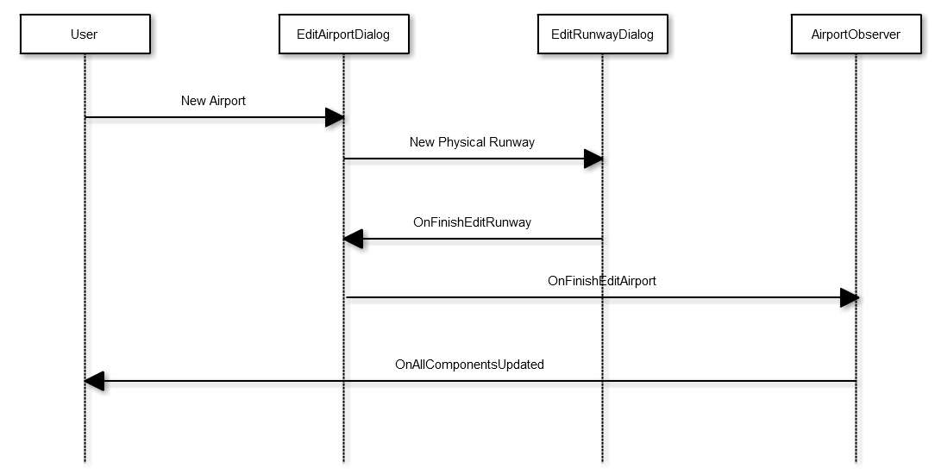

# C:\Users\Edward\SEG\doc\Analysis Design Testing\classDiagram.pngAppendix B – Class Diagram

Appendix C – Use Case Diagram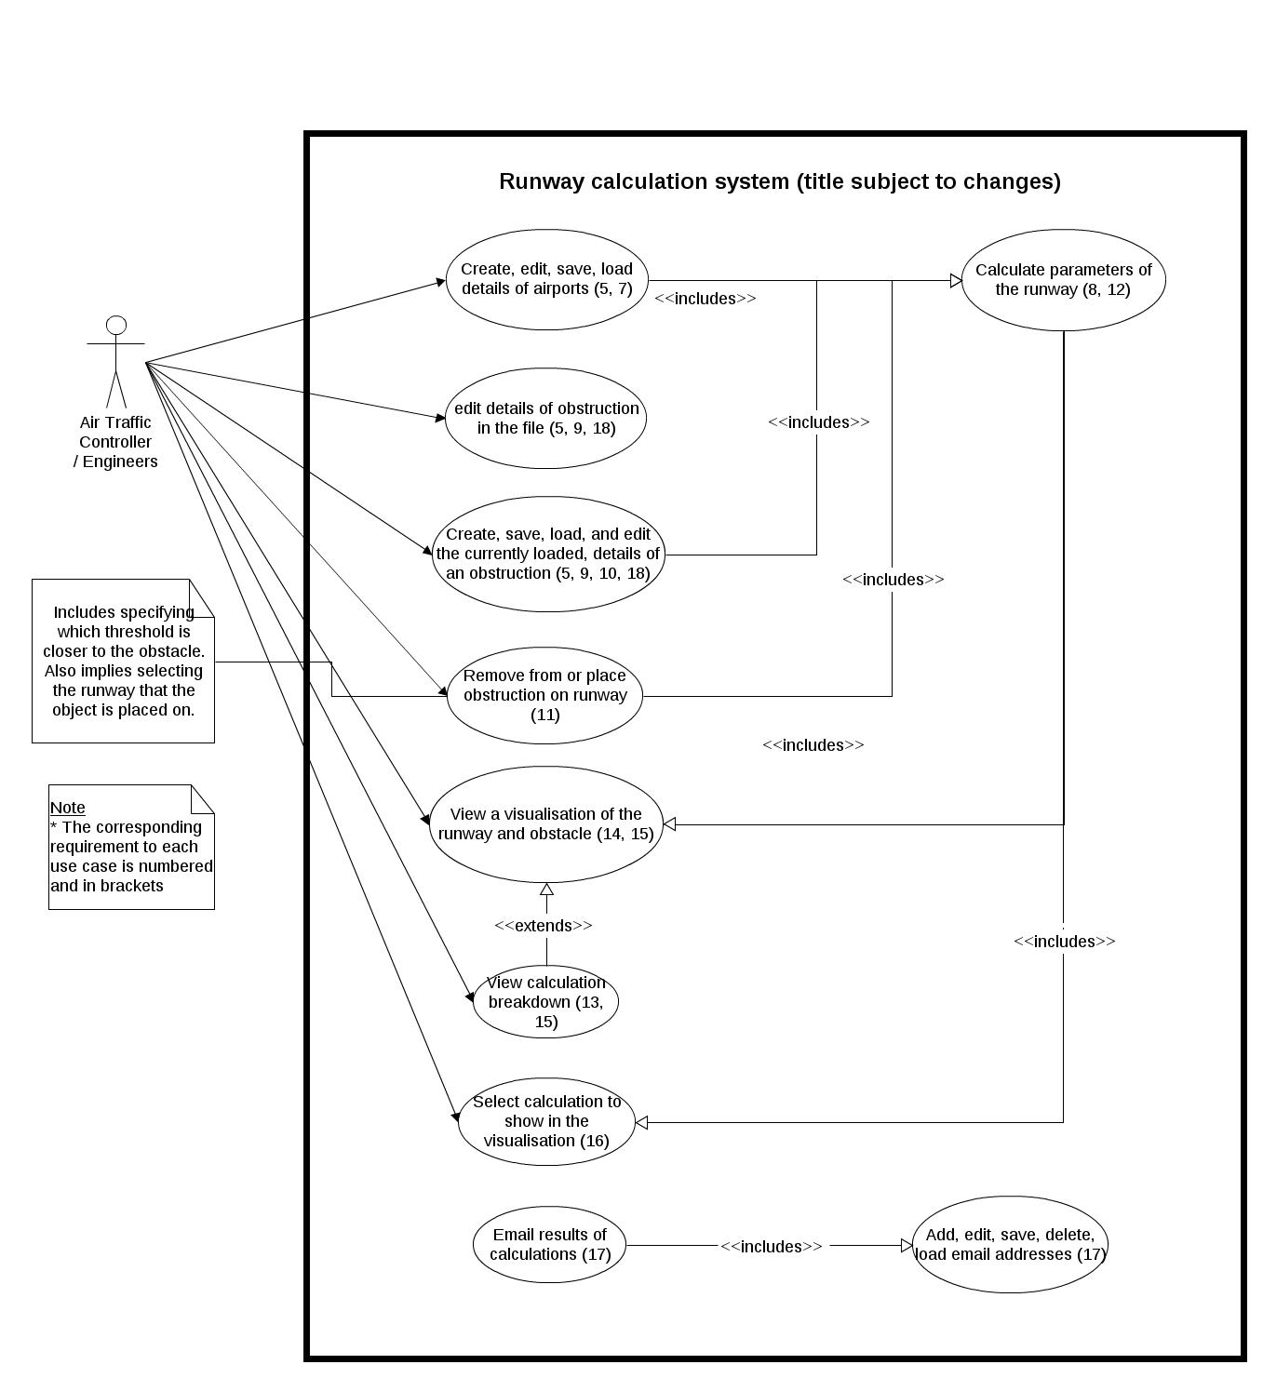

# Appendix D – State Chart

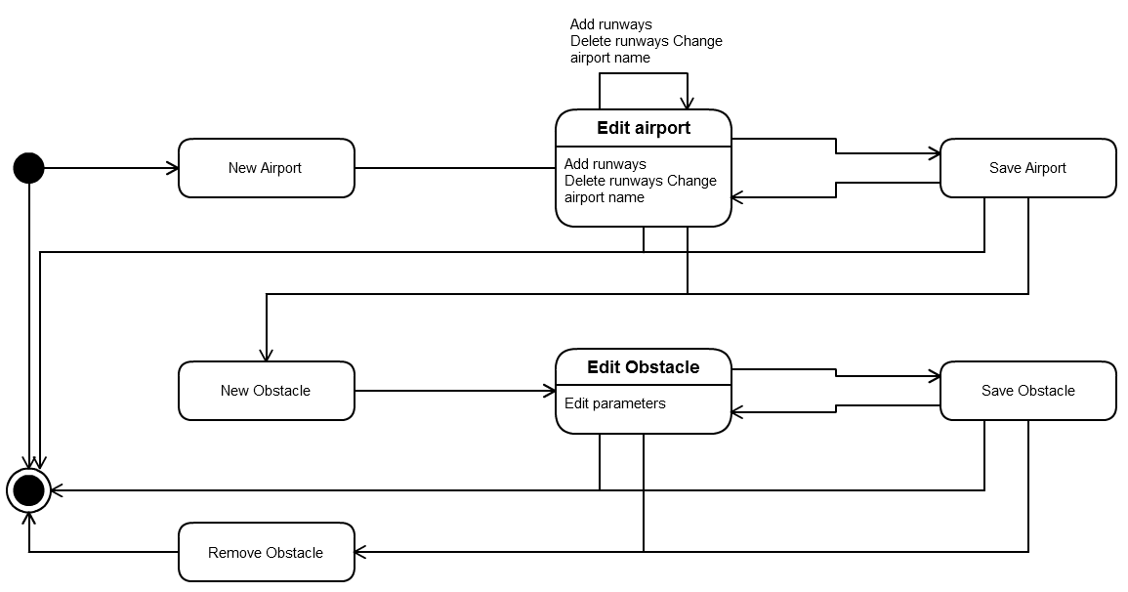

# Appendix E – Wireframes

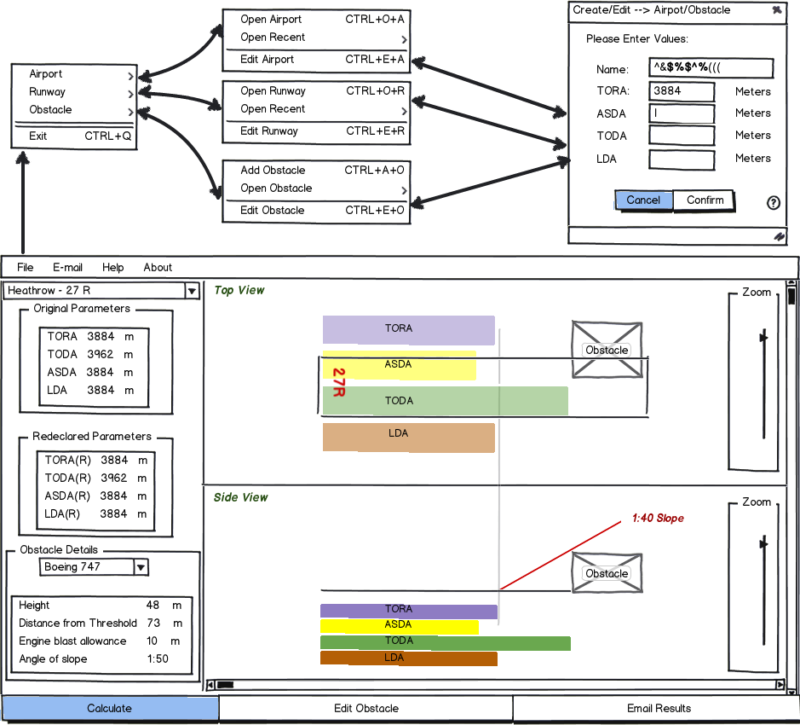

# Appendix F – JUnit Tests

This is an incomplete listing of the JUnit code used to test part of the Model. The image shows the tests passing.  
**package** Model;

**import** java.util.ArrayList;

/** * This class contains test cases in JUnit format for * the implementation of the Model. * **@author** Oscar */

**public** **class** OscarJUnitTests **extends** TestCase{

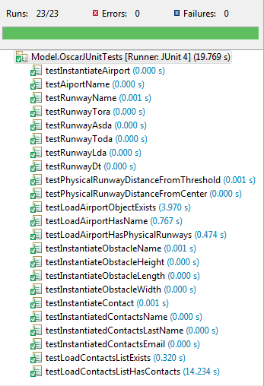**protected** String[] names = {"airport", "b", "c", "d", "e", "f", "g"};  
**protected** **double**[] tora;   
**protected** **double**[] asda;   
**protected** **double**[] toda;   
**protected** **double**[] lda;   
**protected** **double**[] dt;   
**protected** **double**[] awayFromThreshold;   
**protected** **double**[] awayFromCenter;

**protected** **void** setUp(){   
 Random r = **new** Random();  
 tora = **new** **double**[5];  
 asda = **new** **double**[5];   
 toda = **new** **double**[5];  
 lda = **new** **double**[5];   
 dt = **new** **double**[5];   
 awayFromThreshold = **new** **double**[2];  
 awayFromCenter = **new** **double**[2];  
 **for** (**int** i=0; i<5; i++){   
 tora[i]=r.nextDouble()*1000;   
 asda[i]=r.nextDouble()*1000;   
 toda[i]=r.nextDouble()*1000;   
 lda[i]=r.nextDouble()*1000;   
 dt[i]=r.nextDouble()*1000;   
 }  
}

**public** **void** testInstantiateAirport(){

**this**.setUp();

Airport airport = **new** Airport(names[0]);

Runway r0 = **new** Runway(names[1], tora[0], asda[0], toda[0], lda[0], dt[0]);

Runway r1 = **new** Runway(names[2], tora[1], asda[1], toda[1], lda[1], dt[1]);

Runway r2 = **new** Runway(names[3], tora[2], asda[2], toda[2], lda[2], dt[2]);

Runway r3 = **new** Runway(names[4], tora[3], asda[3], toda[3], lda[3], dt[3]);

Runway[] runways = {r0, r1, r2, r3};

PhysicalRunway one = **new** PhysicalRunway(names[5], r0, r1);

one.setDistanceAwayFromThreshold(awayFromThreshold[0]);

one.setDistanceAwayFromCenterLine(awayFromCenter[0]);

PhysicalRunway two = **new** PhysicalRunway(names[6], r2, r3);

two.setDistanceAwayFromThreshold(awayFromThreshold[1]);

two.setDistanceAwayFromCenterLine(awayFromCenter[1]);

PhysicalRunway[] phyRunways = {one, two};

airport.addPhysicalRunway(one);

airport.addPhysicalRunway(two);

*assertEquals*(airport.getName(), names[0]);

**for** (**int** i=0; i<4; i++){

Runway temp = runways[i];

*assertEquals*(temp.getName(), names[i+1]);

*assertEquals*(temp.getTORA(0), tora[i]);

*assertEquals*(temp.getASDA(0), asda[i]);

*assertEquals*(temp.getTODA(0), toda[i]);

*assertEquals*(temp.getLDA(0), lda[i]);

*assertEquals*(temp.getDisplacedThreshold(0), dt[i]);

}

**for** (**int** i=0; i<2; i++){

PhysicalRunway temp = phyRunways[i];

*assertEquals*(temp.getId(), names[i+4]);

*assertEquals*(temp.getDistanceAwayFromThreshold(), awayFromThreshold[i]);

*assertEquals*(temp.getDistanceAwayFromCenterLine(), awayFromCenter[i]);

}

}

.  
.  
.

**public** **void** testLoadContactsListHasContacts(){

ArrayList<Contact> contactsList2 = **null**;

LoadXMLFile lof2 = **new** LoadXMLFile();

**try** {

contactsList2 = lof2.loadContacts();

} **catch** (Exception e) {

e.printStackTrace();

}

*assertTrue*(contactsList2.size() > 0);

}

}

1. SmartSheet Gantt chart software can be found at [www.smartsheet.com](http://www.smartsheet.com)
2. This can be seen in the class diagram in Appendix B
3. Use case diagrams are found in Appendix C
4. London City Airport requires a nonstandard angle of slope
5. Class diagram can be seen in Appendix B
6. The workflow of saving and loading files can be seen in Appendix D
7. Wireframes can be found in Appendix E
8. Sequence Diagram can be found in Appendix A
9. JUnit tests can be found in Appendix F